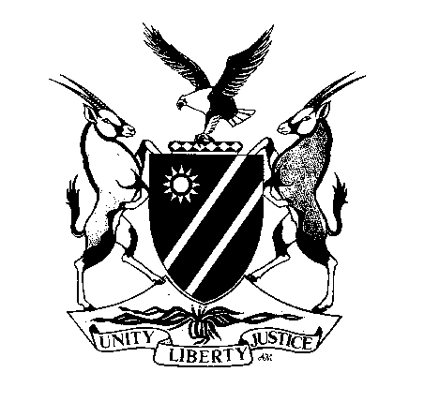
REPUBLIC OF NAMIBIA
MINISTRY OF MINES AND ENERGY

APPLICATION FOR THE RENEWAL OF PERMIT TO PURCHASE, SELL, DEAL IN,
RECEIVE OR DISPOSE OF, OR BE IN POSSESSION OF,
HIGH VALUE MINERALS
(required in terms of section 105 of Minerals (Prospecting and Mining) Act, 1992

I (name of person and/or company): …………………………………………………………………………………………...
of registered postal address: …………………………………………………………………………………………………
hereby apply for the renewal of my HVM permit number: ………………………………………………………………….
issued/renewed on …………………………………………….. for the year of ……………………………………………..

I furthermore state that the particulars supporting my original application/previous renewal application(s) have changed/not changed (delete which is not applicable) during the currency of this year.

In the event of any such changes, I hereby inform you that these are as follows:

1) from ……………………………………………………………………………………………………………………...
to …………………………………………………………………………………………………………………………
2) from ……………………………………………………………………………………………………………………...
to …………………………………………………………………………………………………………………………
3) from ……………………………………………………………………………………………………………………...
to …………………………………………………………………………………………………………………………
and are supported by the attached certified copies (if relevant).

The original Certificate of Conduct (CoC) issued by the Namibian Police must be attached. *
In the case of a company, the original Certificate of Conduct (CoC) of each director must be attached. *
The prescribed renewal fee of N$1 000-00 must be attached to this application.

____________________________ _____________________ ____________
NAME IN FULL (Block Letters) SIGNATURE DATE

* The CoC must not be older than six months on the date of application.

